Machine Problem 4 Report

資工四 胡材溢 B08208032

Your report should include two parts:

1. Briefly answer each problem. If your solutions are reasonable and correct, you can get points. Note that you can get points even if you fail to solve the problems. (10 points)

(a)  Problem 1: Large Files (4 points)  
Please draw your inode block structure and explain how to access 66666th block in your implementation.

Ans:

Inode block structure如下圖所示，除了file metada外，有10個direct blocks、1個single indirect block以及兩個double indirect block。

因為1個direct blocks包含1個data blocks，1個single indirect block包含256個data blocks，1個double indirect blocks包含256*256個 data blocks。因此可以計算出，若要 access 66666th block，會在下圖的第二個 double indirect block中，且由第一層第4個address，第二層第96個address，access 6666th block。

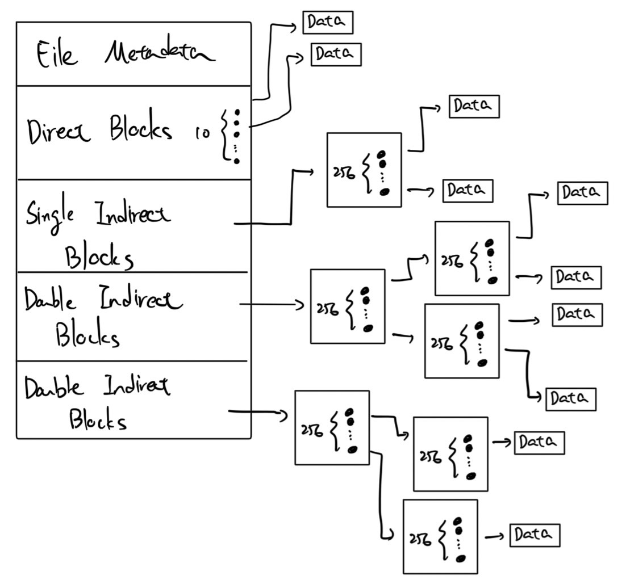

(b)  Problem 2: Symbolic Links to Files (3 points)  
Function symlink(”/b”, ”/a”) creates a symbolic link /a links to file /b, explain how to open symbolic link /a.

Ans:

在sys_open實作中，若要開啟的檔案是 symlink (ip->type == T_SYMLINK)，則會執行一個while迴圈。每次回圈會把存在symlink的內容讀出來，即symlink連結到的檔案名稱，並把該檔案的inode獨進來，並更新ip。若type仍是symlink，就繼續迴圈。除此之外會記錄一個counter，代表while執行了幾次，若超過20則代表出現迴圈，return -1。

(c)  Problem 3: Symbolic Link to Directories (3 points)  
Function symlink(”/y/”, ”/x/a/”) creates a symbolic link /x/a links to directory /y/, explain how to write to /x/a/b.

Ans:

要寫對 /x/a/b 執行寫入的動作，首先要先開起或創建該檔案。用sys_open開啟，執行namei 或 nameparenti時都會呼叫namex。而因為 /x/a/ 為 symlink因此需要先將 /x/a 轉換為 /y/。在namex中的while((path = skipelem(path, name)) != 0) 迴圈裡，若檢查當前讀取到的directory是否為symlink，若是的話會更新 path 以及 ip ， path 就替換 成該symlink指到的目標檔案加上後面的子路徑，例如 /x/a/ -> /y/ ，當我在讀 /x/a/b 的時候，走到 /x/a/ 時發 現它是symlink，我就更新 path 成 /y/b/ 並且將 ip 重新指到根目錄。讀到檔案之後再access相對應的data blocks進行寫入。

2. We encouraged you to help other students. Please describe how you helped other students here. You should make the descriptions as short as possible, but you should also make them as concrete as possible (e.g., you can screenshot how you answered other students’ questions on NTU COOL). Please note that you will not get any penalty if you leave it empty here. Please also note that this bonus is not for you to do optimization, so we will not release the grading criteria and the grades. Regarding the final letter grades, it is very likely that this does not help — you will get promoted to the next level only if you are near the boundary of levels and you have significant contributions. (0 points)

Ans:

幫同學找出錯誤，以及解決寫作業時遇到想法卡住的問題。

